|  |  |
| --- | --- |
| http://www.bestappsforkids.com/wp-content/uploads/2012/04/save-turtle.png | ***Turtle exercise*** |

1. Write a Python function that draws a square, named draw_square, takes 2 input parameters: length and color, where length is the length of its side and color is the color of its bound (line color)
2. Now, another programmer named Huy be will use your code in exercise 1. He writes as follows:

**for** i **in** range(30):  
 draw_square(i * 5, **'red'**)  
 left(17)  
 penup()  
 forward(i * 2)  
 pendown()

Copy this code into your editor, run the whole program and see what it draws:

*Note: If your code does not run, try not to modify Huy be’s code, modify your function instead*

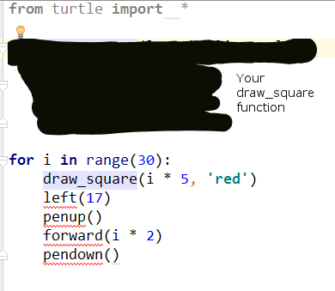

1. Write a Python function that draws a star, named draw_star, take 3 parameters: x, y, and length. Where x, y are the location of the star, length is the length of its side

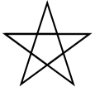

*Hint: Turn 144 degree at each point*

1. Again, your function will be used by other programmers like Hiep want to use your function, they writes as follows:

speed(0)  
color(**'blue'**)  
**for** i **in** range(100):  
 **import** random  
 x = random.randint(-300, 300)  
 y = random.randint(-300, 300)  
 length = random.randint(3, 10)  
 draw_star(x, y, length)

Copy this code into your editor, run the whole program and see what it draws:

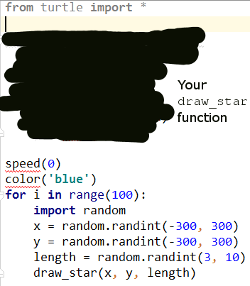

Explain the random.randint(…) statement, what it is, and how to use it?

random.randint(…) trả về 1 số interger với giá trị nằm trong khoảng mà đã khai báo, như ví dụ là 1 số nguyên trong khoảng >=-300 đến <=300

|  |  |
| --- | --- |
| http://images.8tracks.com/cover/i/001/358/131/7357.original-3735.jpg?rect=0,29,289,289&q=98&fm=jpg&fit=max&w=100&h=100 | ***Serious exercise*** |

1. Write a function that removes the dollar sign (“$”) in a string, named remove_dollar_sign, takes 1 parameter: s, where s is the input string, returns the new string with no dollar sign in it

*Hint: Google “Python string replace remove”*

1. Now, another programmer named Hiep will use your code in exercise 3. He writes as follows:

string_with_no_dollars = remove_dollar_sign(**"$80% percent of $life is to show $up"**)  
**if** string_with_no_dollars == **"80% percent of life is to show up"**:  
 print(**"Your function is correct"**)  
**else**:  
 print(**"Oops, there's a bug"**)

Copy this code into your editor, run the whole program and see what it prints out:

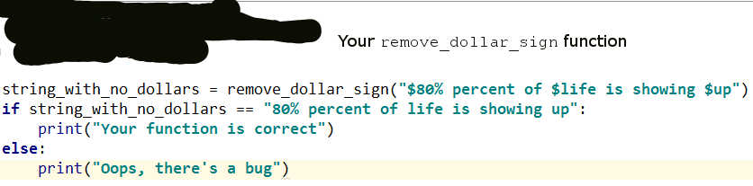

If it prints out **“Your function is correct”**, we’re good

If it prints out **“Oops, there’s a bug”**, you might want to come back and check your function

1. Write a function that extracts the even items in a given integer list, named extract_even, takes 1 parameter: l, where l is the given integer list ([1, 4, 5, -1, 10] for example), returns a new list contains only even numbers ([4, 10] if the given list is [1,4,5,-1,10])
2. Let’s take your function to the test. The tester will write his/her test code as follows:

even_list = get_even_list([1, 2, 5, -10, 9, 6])  
  
**if** set(even_list) == set([2, -10, 6]):  
 print(**"Your function is correct"**)  
**else**:  
 print(**"Ooops, bugs detected"**)

Copy this code into your editor, run the whole program and see what it prints out:

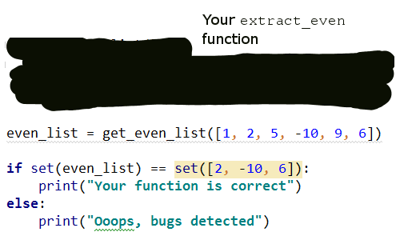

If it prints out **“Your function is correct”**, we’re good

If it prints out **“Oops, bugs detected”**, you might want to come back and check your function